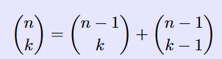

Have a table and a priority queue, both of size N. Both contain the same elements. Initially both contain the numbers Cr(n+2, 2) for n < N. The priority queue is kept sorted. At each step the top two elements are compared for equality. Afterwards the top element is discarded. When Cr(n+k, k) is discarded, the new value Cr(n+k+1, k+1) is added, unless k>=n. The new value needed is computed from the old one via Cr(n+k+1, k+1) = Cr(n+k, k) + Cr(n+k, k+1). Note that the value Cr(n+k, k+1) is present in the table at index n-1 at the moment it is needed.

I do not understand this part, “At each step the top two elements are compared for equality. Afterwards the top element is discarded.” So we compare the top 2 elements of the priority queue for equality, if equal, discard both and add the number into collision list, if not equal, then discard the top element only.

“When Cr(n+k, k) is discarded, the new value Cr(n+k+1, k+1) is added, unless k>=n.” OK

“The new value needed is computed from the old one via Cr(n+k+1, k+1) = Cr(n+k, k) + Cr(n+k, k+1). Note that the value Cr(n+k, k+1) is present in the table at index n-1 at the moment it is needed.” I don’t get this part, because “Initially the table contains the numbers Cr(n+2, 2) for n < N”. As far as I can see, the content of the table has not changed throughout, so the table does not contain any other number than Cr(n+k, k+1) where k+1 != 2?

Can someone enlighten me please or perhaps provide with source code in C or Python?

Thank you very much!

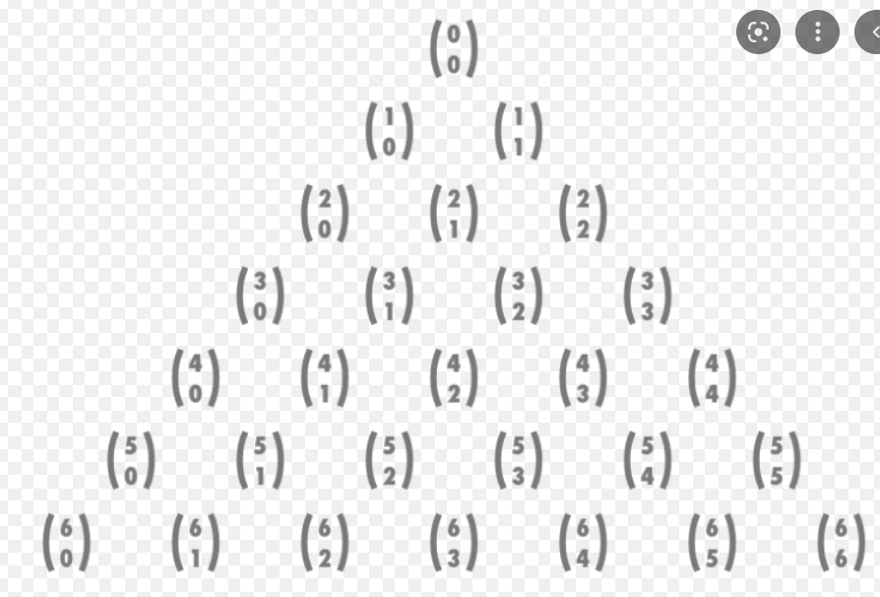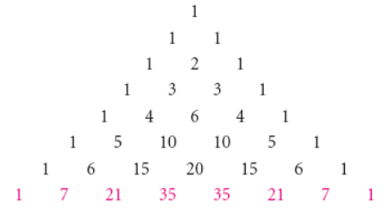

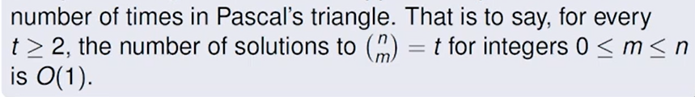

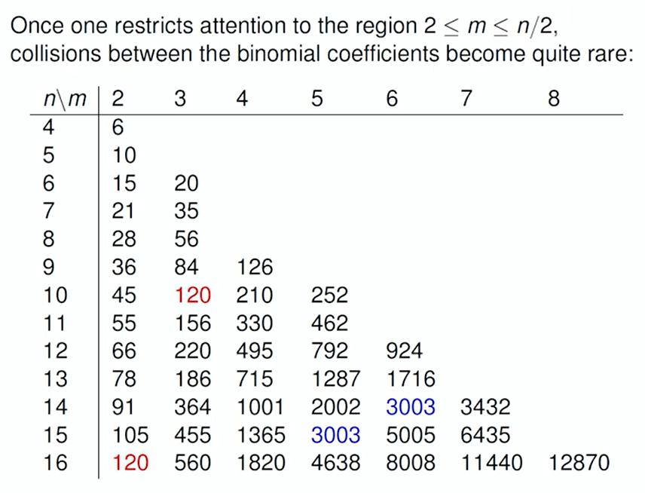

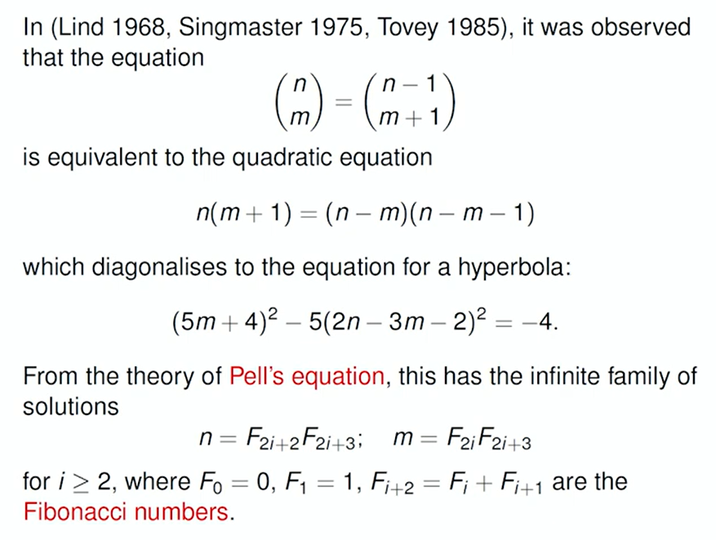

**0, 1, 1, 2, 3, 5, 8, 13, 21, 34, 55, 89, 144, 233, 377, 610, 987, 1597, 2584, 4181**.